To install mods Copy and paste this whole filepath into the File Explorer searchbar to find the correct folder:
C:\Program Files (x86)\Steam\steamapps\common\Mount & Blade II Bannerlord\Modules

I know some of you have an IQ of only 72.
I promise!! Installing mods for Mount & Blade Bannerlord is easy!
You only need to learn how to use Microsoft File Explorer:

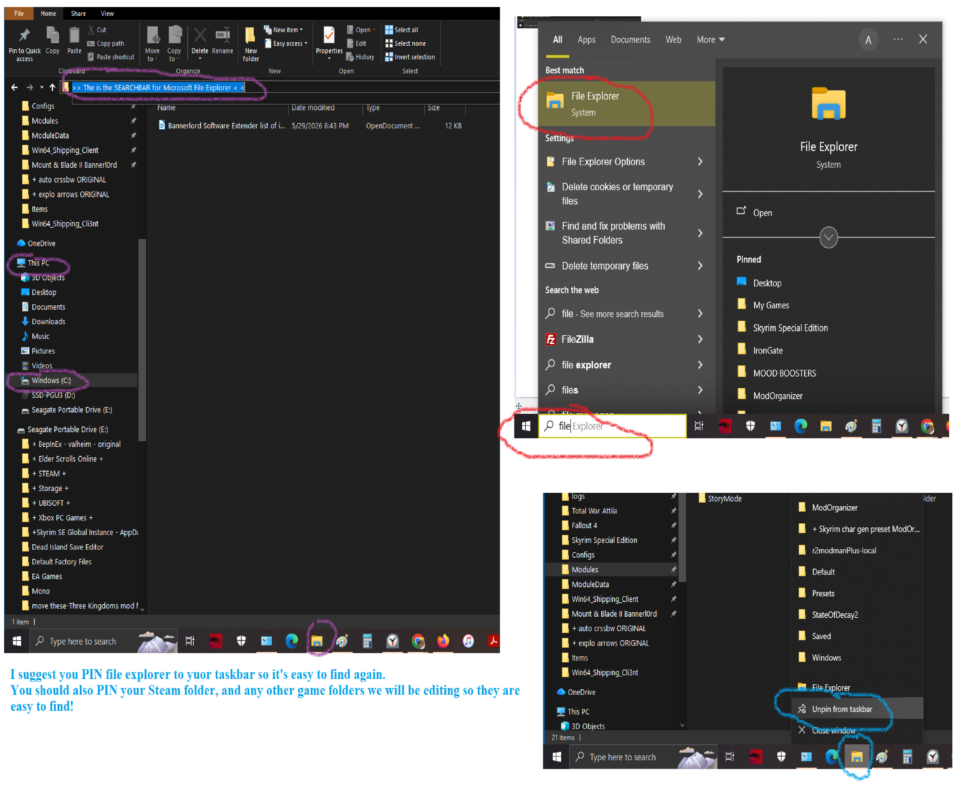
To install mods
Copy and paste this whole filepath into the File Explorer searchbar to find the correct folder:

C:\Program Files (x86)\Steam\steamapps\common\Mount & Blade II Bannerlord\Modules
Let’s PRACTICE installing your very first mod:
https://www.nexusmods.com/mountandblade2bannerlord/mods/10426?tab=videos

To install Bannerlord Software Extender
Copy and paste this filepath into the searchbar to find the correct folder:

C:\Program Files (x86)\Steam\steamapps\common\Mount & Blade II Bannerlord\Bin\Win64_Shipping_Client

In the Win64_Shipping_Client folder you just found Copy and paste only these items from the Bannerlord Software Extender zip file:
Bannerlord.BLSE.AppDomainManager.dll
Bannerlord.BLSE.Launcher.exe
Bannerlord.BLSE.Launcher.exe.config
Bannerlord.BLSE.LauncherEx.exe
Bannerlord.BLSE.LauncherEx.exe.config
Bannerlord.BLSE.Shared.dll
Bannerlord.BLSE.Standalone.exe
Bannerlord.BLSE.Standalone.exe.config
TaleWorlds.MountAndBlade.Launcher.exe.config
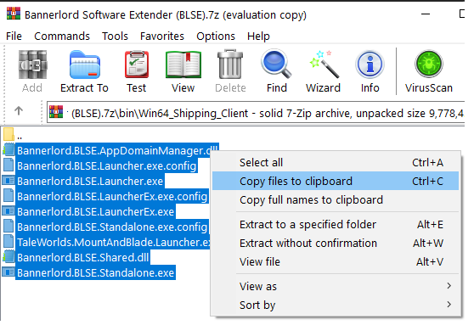

Do NOT drag and drop the entire Bin folder or Win64_Shipping_Client folder you see!!

Do NOT overwrite folders that already exist in your copy of Bannerlord or you will break your game!!

Create a shortcut for BLSE launcher on your desktop

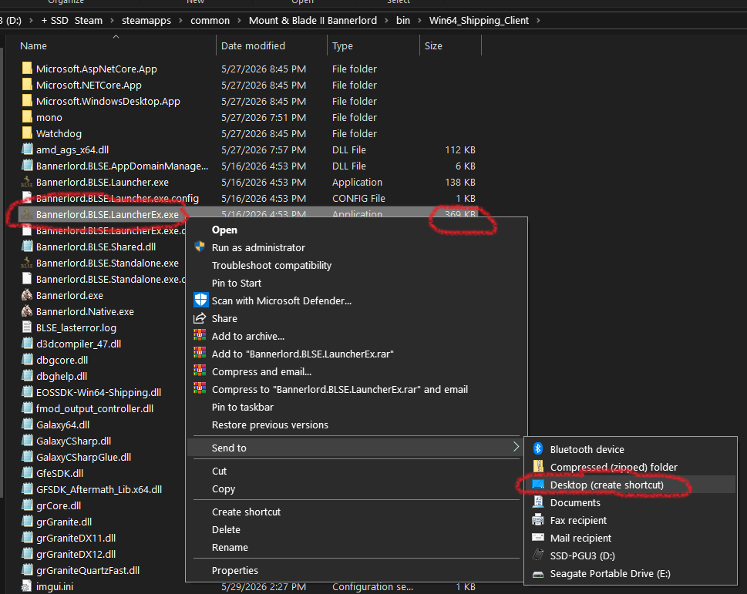
Use the version of BLSE Launcher that is 369 KB because it is the most advanced Bannerlord launcher and will allow you to save or import mod your load order for convenience!

Here’s what the software extender launcher looks like:

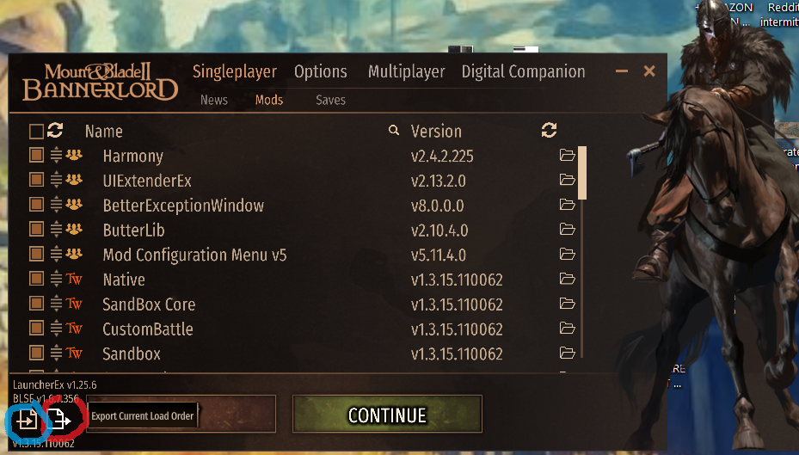
I’m going to send you a copy of my mod load order for you to import to make things easier for you.

Last but most important:
You must install Unblock DLLs downloaded from Nexus Mods

https://www.nexusmods.com/mountandblade2bannerlord/mods/397?tab=files

I would just copy and paste the 2 items you downloaded into this directory:

C:\Program Files (x86)\Steam\steamapps\common\Mount & Blade II Bannerlord\Modules

Would be easiest to save the Bannerlord Software Extender Load order file I send you to your Desktop wallpaper.

